Newsletter
CHARLESTON HARBOR HOMES ASSOCIATION - KANSAS CITY
Spring/Summer 2018

THE POOL IS OPEN!
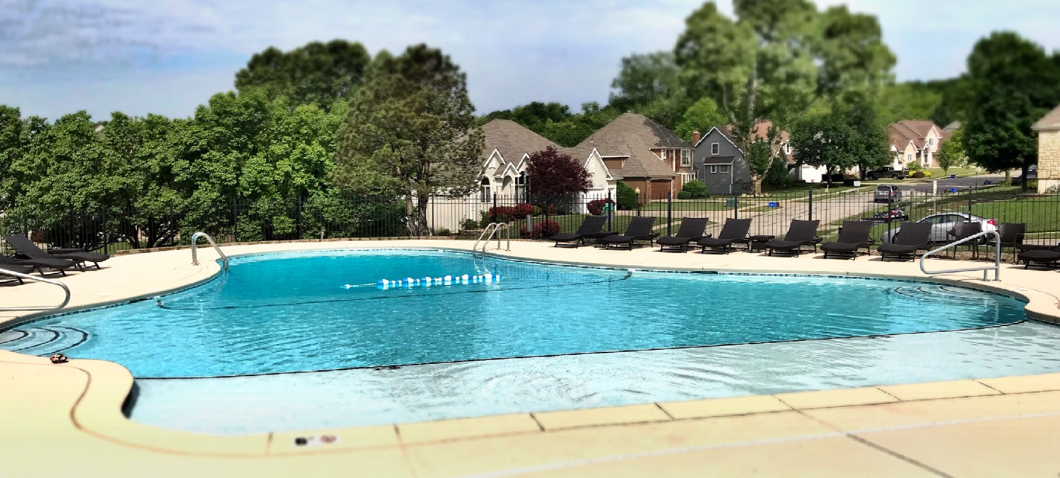
Our pool has been extensively renovated since last season with the addition of a six inch deep, 11x 32 foot “tanning ledge.” Modifications were made to the coping of the pool to prevent tile separation, leaking filter/skimmers were replaced, new waterline tile was installed and the entire interior of the pool was cleaned and resurfaced with an “inter-glass” material designed to last 25+ years. The feedback from residents has been overwhelming!
There is a renewed interest by our residents in pool use. The pool entry locks were upgraded two seasons ago to deter non-residents from using the pool. We now use proximity cards to get in and out of the pool area. Each household receives a complementary card. There is a fee to purchase extra cards or replace lost cards. If you have not yet received your card, please download and complete the registration form at http://www.charlestonharbor.org/community-pool.html. You can then email your form to Charlestonharborprez@gmail.com. You can also mail it in to CHHA 6715 N Charleston Dr KCMO or drop it off. Pool cards will not be issued without an accompanying registration form. Remember your pool cards are good year after year. Don’t throw them away!
We ask all members NOT to allow people into the pool area with their card. We have had issues with trespassers claiming they forgot their card and being let in by residents. Someone recently violated city ordinances and put us at risk of having the pool closed. The circumstances were reviewed and a pool card was suspended for two weeks. If you let someone in, you will assume responsibility for that person’s actions. If someone asks you to give them entry into the pool, please ask them to go get their card. If they claim they have a problem with their card, please direct them to contact the board at Charlestonharborprez@gmail.com. Pool cards will not be available June 15 through June 22.
NOTE: Please remember that SMOKING & GLASS ITEMS ARE PROHIBITED IN THE POOL. Do not have cigarettes or glass inside the gates or on the deck! Don’t bring it in when you scan in….

MANAGEMENT COMPANY HIRED!
The board of directors has engaged Brookwater Management LLC to take on the day to day operations of Charleston Harbor. They will take over bill paying responsibilities from our accountant as well as some of the legal responsibilities of our attorneys. Home owners will be receiving more information about this change in the mail within the next month. This change was necessitated to properly manage our records and run the day to day operations appropriately.

BOARD OF DIRECTORS ELECTIONS COMING SOON!
Charleston Harbor’s Annual Members’ meeting is scheduled for August 28 at the Shoal Creek Patrol Building. The official notice and call for nominees along with full details will be provided in early July. We expect a nearly complete turnover of the board this year and we strongly encourage residents to participate in the election process as well as to serve on the board. If you would be interested in helping the neighborhood by serving on the board please, email either Charlestonharborprez@gmail.com or chhawebmaster@yahoo.com. If you don’t do email, please address your letter of interest to CHHOA 6715 N. Charleston Drive, KCMO 64119
The Board of Directors for Charleston Harbor Homes Association, Inc. are volunteer positions. We anticipate a more streamlined process in the years to come with the help of Brookwater Management. Pool, Lake, Landscape, Social, Yard lighting, Safety & Security and other committees need your involvement! Please take an hour or two out of your month and participate on a committee.

UPCOMING PROJECT
With the donation by our residents of two lots on Quincy Avenue and with the cooperation of our developer, the landscape committee has recommended a three year development project for these Quincy Ave common areas. Work will be done in stages over the next three years to develop a park area with a patio, a pavilion or pergola and landscaping. Our goal for 2018 is to clean the lots, develop grass and landscaping to curb erosion and water runoff.

OTHER NEWS
We recently completed repairs and upgrades to the dam at White Rock Lake. The top of the dam was raised and leveled, an actual spillway was installed and the face of the dam was covered in white “rip-rap.” New grass was planted this spring. Lake Committee volunteers have taken on lake maintenance including algae control, colorant, and weed control. Our volunteer’s time and efforts are saving our residents thousands over the course of the year as opposed to contracting this work out.

