NOMINEE BIOGRAPHIES
The residents listed below have shown an outstanding interest in improving our community. Please support the following nominees by voting for them at the August 25 Charleston Harbor HOA member meeting. If you cannot attend, proxy ballots are available.

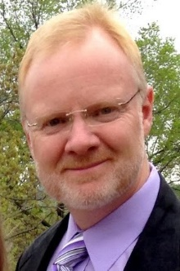
Karl Bloss moved to the USA from Germany at age 8, and has lived in Charleston Harbor with his wife Kristina and two children since July 2014. He has worked for Bayer for 14 years and held various engineering positions in locations such as West Virginia, Michigan, and most recently Germany. Karl is interested in becoming a member of the Charleston Harbor HOA Board and would offer to take the Treasurer position. In addition to knowing his way around a spreadsheet as part of his engineering background, relevant experience includes past small business ownership and treasurer duties of his son’s Cub Scout Pack and Boy Scout Troop.

Karl believes in a transparent approach to bookkeeping (including CPA audits), open and fair bidding processes, and full membership access to documentation. All homeowners should be able to know where the Association’s money comes from and how the Board is allocating those funds for the betterment of the neighborhood.

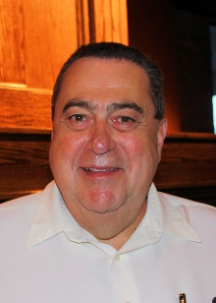
Larry Janacaro has lived in Charleston Harbor with his wife Patty for 8 years. They both have lived in the Clay/Platte area all their lives. Larry and Patty have two children and four grandchildren living locally. Larry is retired after 45 years in the Banking/Trust industry.

Larry’s immediate goals for Charleston Harbor include maintenance addressing issues with the lake and lighthouse. He wants to see open communications between association members and the board of directors. Larry’s goals include transparency with our bookkeeping in regards to collection and distribution of finances. Larry’s long term goals for our association include acquiring common land for pocket parks in our middle and northern sections. These can be developed for green areas, picnic tables, gazebos, and/or fire pits to foster community socialization.

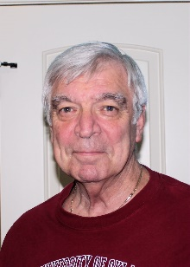
Joe McCune was born in Muskogee, OK and has lived in KC over 65 years. Joe graduated St. Pius X and attended CMSU in Warrensburg. Joe is a retired Kansas City police officer and served on the force for 26 years. Joe is also contracted with the United States Marshal’s Service and has been with them the last 13 years. Joe and his wife Mary have lived in Charleston Harbor 9 years.

Joe is also licensed in real estate and worked for Re/Max 8 years. He has served on Charleston Harbor’s board in the past. Joe is well versed in property values and wants to contribute his real estate knowledge to help grow our association’s asset values.

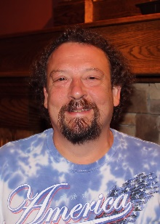
Tim Moon was born and raised in the Northland and has always been proud to call the Northland home. Tim believes it is the best part of Kansas City combining suburban and rural areas. Tim has worked for KCFD/MAST since 1998 and has been a Certified A.S.E. Master Technician for 30 years. He holds an A.A. degree in technology and has served as an executive board member and Union Steward during his tenure with KCFD/MAST. Tim resides here in Charleston Harbor with his wife of 22 years, Cathy.

Tim believes we as neighbors have a unique chance to make Charleston Harbor a true gem of the north.
Tim sees the lake and the lighthouse are priorities for our association to address. He would like to see to our association develop a plan to save a percentage of the dues every year for future projects.

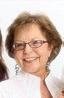
Karla Oyler has been a resident of Charleston Harbor for eight years. She was raised in Gladstone, attended NKC High School, and graduated from UMKC. Karla attended William Jewel College as well. Karla started with Farmland Industries, then worked 24 years at Arthur Andersen, accounting/consulting firm. As an administrative manager, Karla purchased and implemented computer, communications, and automation systems; developed and conducted training, locally and firm wide. She managed office services and personnel; was project manager for office renovations and relocations. Karla did consulting work after retirement, but now focuses on volunteering at North Kansas City Hospital and Davidson Elementary school. Her two adult sons and their families live nearby.

Karla serves on our welcome committee and would like to see the following for Charleston Harbor residents: Financial audits instituted and detailed budgets, bylaws updated. See us form a committee or have an advisor to interact with KCMO, builders, and lot owners to improve neighborhood infrastructure/appearance. She would like to see competitive bids for pool maintenance service and security system and see issues like our bridges, lake, lighthouse and geese addressed.
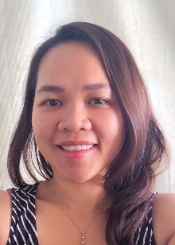
Erin Pham was born in Vietnam and moved to KC when she was 9. Erin is fluent in English and Vietnamese. Erin and Mike both work for Farmers Insurance. They have two daughters, Addison 3 years old and Audrey is 9 months old. They moved to Charleston Harbor (Their first home!) on New Year’s Day in 2014.
Erin’s goals for Charleston Harbor are to see more social events (block parties/picnics/BBQ, spring and fall garage sales) established so that neighbors have more opportunities to meet one another. She also hopes to see more child friendly social events such as ice cream socials. (A great opportunity for kids to meet other kids), Erin see the potential for walking clubs and other activities as well. Erin sees the need to clean up our lake. ”The lake was one of the highlights when we moved into this neighborhood.” Erin would like to see upgrades to entrances so that we make a better first impression for those driving by as well make them more inviting for our membership.

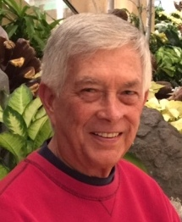
Marlin Roberts and his wife Linda, have lived in Charleston Harbor for 5 years, and in the northland since 1974. They have two grown sons and two granddaughters. Marlin worked for the MO Dpt. of Education (Div. of Vocational Rehabilitation) for 30 years as a counselor and in management as a district supervisor of field office staff and budget. He served as Dir. of Rehabilitation Services for Jewish Vocational Service for four years. Marlin retired in 2005. He has been the Charleston Harbor Homes Association webmaster for the last three years. Marlin is currently Chairperson on our Communications Committee and serves on our Yard Light, Welcome and Safety & Security committees.
Marlin would like to contribute time and effort to strengthen neighborhood involvement. Move forward with projects to repair/improve infrastructure of our HOA, its assets and amenities. Prioritize such projects with input of thoughts, ideas and suggestions from our homeowners.

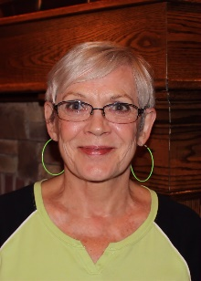
Alice Roxburg is interested in living in a vibrant community and understands that the residents must be involved in order for this to happen. Alice grew up in KC and worked for Sears. Alice moved through the ranks at Sears as a salesperson, Department Manager, Distribution Assistant and Merchandise Manager. Alice and her husband lived in a 2000 home gated community for residents 55 and over in Phoenix, AZ. They were involved with various committees and were community organizers. Alice returned to KC after the passing of her husband. Alice has a large family including 3 children, 11 grandchildren and 26 great-grandchildren.

The health of the lake is one of Alice’s biggest concerns. She believes the lake and the lighthouse should have top priority in the next year. Alice would also like to see our association develop a "social committee" and have annual neighborhood social events to become better acquainted.

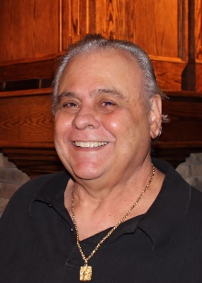
Frank Russo and his wife Betty have lived in Charleston Harbor for 8 years. Frank has been a lifelong KC resident and grew up in the NE sector. Frank is retired from owning and operating his own restaurant and bar (FraJoes). Frank studied commercial art at the KC Art institute. Frank is a member of American Sons of Columbus and managed the local chapter’s properties. Frank and Betty have two adult children that live locally.

Frank has served on Charleston Harbor’s Board in the past. Frank would like to see us be to build our financial reserves, have our board address issues in a timely and responsive manner and restore neighborhood pride through consistent adherence to our governing documents. Long term Frank would like to see our association build a clubhouse on common properties.

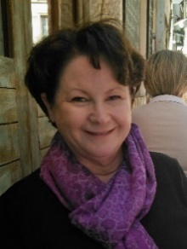
Jerusha White grew up on a 300 acre farm near Sedalia, MO where her family raised registered Black Angus cattle. Jerusha went to undergraduate school at CMSU in Warrensburg and UMKC Law School where she graduated in 1981. She practiced law in her own practice in Sedalia for 3-4 years and then came back to KC in 1986 where she was hired by the U.S. Army Corps of Engineers. Jerusha’s specialty was government acquisitions, reviewing contracts and litigating claims, primarily in military construction. She retired from the Corps in 2006 and since then has been writing a family history book, which is nearly completed. Jerusha moved to Charleston Harbor in 2010.

Jerusha believes the lake and lighthouse to be important assets for our association and would like to see our efforts focused on restoring both.

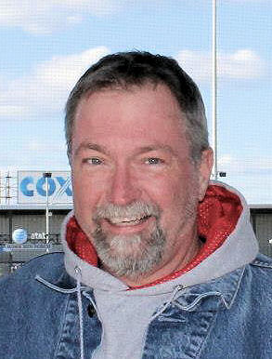
Charles “Chaz” Wood was born and raised in Platte Woods. He and wife Ronda raised their two daughters in Liberty. Chaz and Ronda moved to Charleston Harbor July of 2014. Chaz has been with the Union Pacific Railroad as a machinist for 17 years. He served as the IAM’s local chairman for 9 years and is experienced dealing with various labor/management issues and governing agreements. He and his wife Ronda are expecting their first grandchild in September.

Chaz would like to see our lake cleaned up and lighthouse repaired to be an exemplary landmark for the Northland. He would like to see our board adopt more transparent business methods and reinstate annual audits. His goal is to make positive progress on updating our declaration, covenants and restrictions.

