2018/2019 NOMINEE BIOGRAPHIES
The residents listed below have shown an outstanding interest in improving our community. Please support your community by voting for 7 board members at the August 28 Charleston Harbor HOA member meeting. If you cannot attend, proxy ballots are available included.

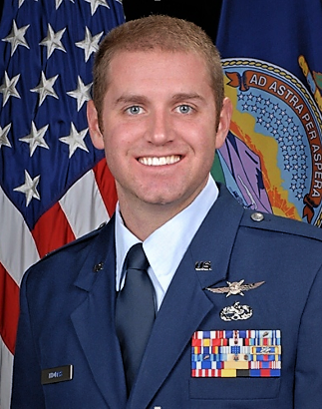Josh Thomas was born and raised in St. Joseph, Missouri. In 2010, he graduated with a Bachelor of Science in Electrical Engineering from the University of Missouri. He moved to the KC area when he accepted a job at Honeywell, located in South KC. Josh works as a Senior Cyber Security Analyst where he is tasked to keep Honeywell’s proprietary information safe; providing computer security services for Honeywell. Josh served in the United States Air National Guard for over 16 years and is currently serving as the Cyber Operations Officer at Forbes Air Field, Topeka, Kansas. Josh and his wife Kayla, moved to Charleston Harbor this past February. Josh and Kayla both enjoy running local 5k’s for charity and they also volunteer with the Veterans Tiny Home Project each year.
If elected, Josh would use his proven critical thinking and problem-solving skills to address any recurring or known concerns within Charleston Harbor. He would begin brainstorming innovative ways to improve participation in the neighborhood. He would also assist in prioritizing community improvements, providing the best return on investment. As a board member, Josh would like to create a five-year plan with appropriate milestones that address current and future amenities.

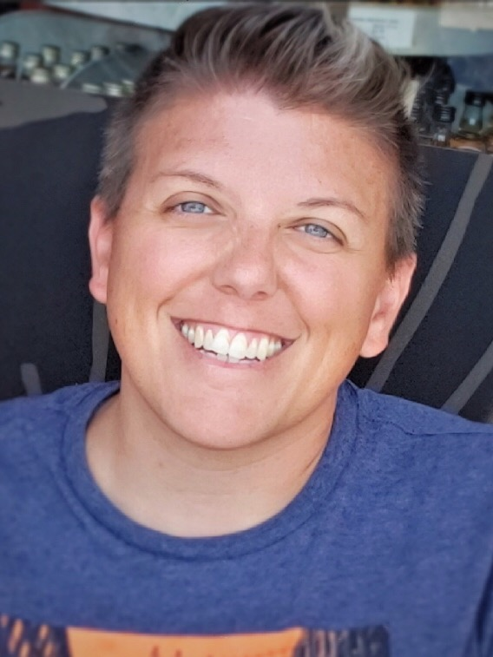Katie Wienke was raised in Lee’s Summit, Missouri. She attended Lee’s Summit High School where she competed in soccer and softball. Katie went on to study at the University of Central Missouri and graduated with a degree in Criminal Justice. Katie has worked in the legal field for the past eight years and currently works at Husch Blackwell LLP as a paralegal. Katie and her partner moved to Charleston Harbor in July of 2017. Katie enjoys the beauty and quietness of Charleston Harbor. She enjoys being a part of the community here. Katie enjoys attending car shows with her 68’ Camaro and going on evening rides in her dune buggy.

Katie’s primary interests are to maintain the physical property in top condition and to keep the HOA financially strong.

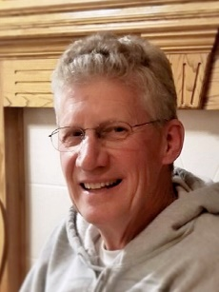
Paul A. LaVine was born and raised right here in KCMO. Paul and his wife, Kathy have been married 41 years. They have two sons, Clayton and Caleb and two grandchildren, Chase and Ali. Paul is a retired Teamster from Yellow Freight and has retired from the North Kansas City School District as a bus driver after seven and a half years. Paul and Kathy have lived in Charleston Harbor for the last three years. Paul is an avid Royals fan and drives a chase/support vehicle in races down in Baja.
Paul has volunteered his truck, trailer and other equipment for Charleston Harbor’s spring and fall clean up events. He has gone door to door to pick up items for residents who could not make it down to the dumpsters. Paul was appointed to the board of directors this past year and would like to see our community continue to our grow property values and would like to eventually have the lake and entrances gated.

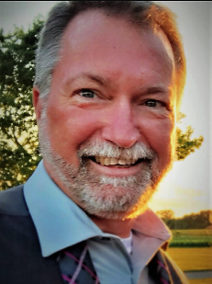
Chaz Wood was born and raised in Platte Woods. He and wife Ronda raised their two daughters in Liberty. Chaz and Ronda moved to Charleston Harbor July of 2014. Chaz has been with the Union Pacific Railroad as a machinist for 20 years. Chaz has served as board president since 2015 and volunteers on the architectural review committee, lake committee, light committee, and has donated his time in updating the lighthouse including paint, beacon lighting and exterior floodlights, improving the lake, improving the pool, repairing the dam, and replacing the bridges.
Chaz worked with the board in re-instituting the required annual financial audit/review as required by our governing documents. He would like to see our governing documents updated, grow our emergency funds and continue to maintain and improve our amenities. Chaz believes we need to develop long term and short term goals for our amenities and common areas.
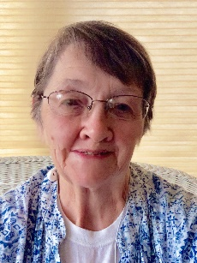
Kay Foxe was born in Kansas City and raised near Warrensburg. Kay attended UCM which was CMSU at that time. She moved back to Kansas City in 1959, so has lived here for almost 60 years. Kay is married to David Foxe and they have been married for 55 years. They have 2 daughters, one living in Olathe, with 2 children, a boy and a girl. The other daughter lives in Colorado and has 2 girls and 1 boy.
Kay worked for TWA for 8 years then the North Kansas City School District for 27 years. She was admin assistant, and then worked in Information technology, working with the student database, the library system, and some networking.
Kay volunteers at the Atkins-Johnson Farm and Museum in Gladstone. She has volunteered at the Northland Shepherd’s Center, taking tickets for Starlight Theatre, driving elderly people to appointments, working on registration for the annual fundraiser, and the Adventures in Learning lunch and program. Kay and her husband David have lived in Charleston Harbor since 2005. You will see her out walking in the morning and picking up neighborhood trash. They have both volunteered with the neighborhood clean-up and the Brighton/Pleasant Valley Road cleanup.
If elected, Kay wants to see maintenance on current projects and would like to make sure dues and current monies are spent wisely and well. Kay wants to see Charleston Harbor to continue to be a great place to live and grow. Attitude is everything!!

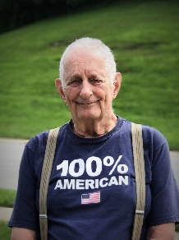
Ronald Davisson is a graduate of Raytown High school and has lived in Charleston Harbor since February, 2017. Ronald served his country in the United States Air Force and worked for Ford at the Claycomo Assembly Plant. After retiring from Ford, Ronald was hired by the Missouri Department of Corrections at the age of 80. Ronald was the oldest sergeant in the state before retiring and moving to Charleston Harbor. Ronald has traveled to Germany, England, North Africa, Israel, Okinawa Island and Japan.
Ronald believes in a common sense approach to problem solving that he would like to apply in serving on the board of directors.

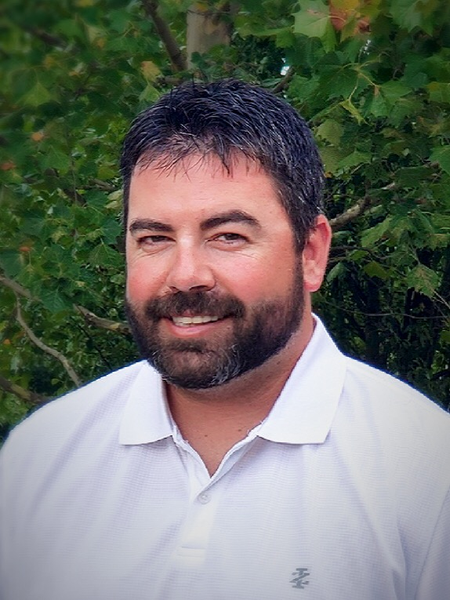Robert Sullivan was born in Dodge City, KS and grew up in Wichita. He was involved with Boy Scouts of America and achieved his Eagle Scout rank in 2001. Robert attended Kansas State University-Salina where he studied Aeronautical Science with a minor in Business Management. After college, Robert moved back to Wichita continuing his love of aviation. He met his wife Tammy shortly after returning back to Wichita. In 2011, Robert moved to Kansas City to take on a career with a local short line railroad. Robert worked his way up to Senior Trainmaster before being hired by the Union Pacific in 2018.
Robert and Tammy moved to Charleston Harbor in 2014. Robert enjoys working on a variety of projects ranging from the house to wrenching on his drag race truck. Robert and Tammy enjoy watching Chiefs and Royals, grilling with friends, and nights outside listening to music. They have 2 dogs, Maddie and Max, who enjoy taking walks around Charleston Harbor and of course, the occasional dip in White Rock Lake.
Robert’s goal is to focus on engaging our community by networking within the community as there are numerous amenities within Charleston Harbor that will only be able to be completed with the support/connections of the CH community to help keep our cost minimal. He is a firm believer in transparency and maintaining traditional midwest values, while thinking outside of the box to help provide effective solutions and community engagement.

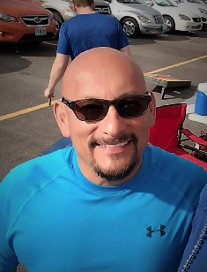
Carlos Hernandez and his family have lived in Charleston Harbor since 2001. Carlos has been a lifelong resident of Kansas City. Carlos graduated in 1980 from St. Pius and went to work for Bendix/Allied Signal/Honeywell as an Electronic Assembler. In 1992, he went back to school and graduated in December of 1993 with a Bachelor of Science in Computer Science from Rockhurst University. He went to work for a small company called Cerner Corporation in January of 1994 as a software engineer. Carlos directed a large group of technology consultants and architects across the US and also had a team of software engineers in India. He was responsible for delivering fourteen million dollars of revenue each year, managing hundreds of projects concurrently, interacting between engineering, finance, sales, human resources, and consulting, and developing new software solutions for Cerner.
Since retiring, Carlos served on the board last year and was involved with the lake committee. Carlos volunteers his time treating the lake for algae. As a Northlander for the better part of his life, he firmly believes the location, amenities, and beauty of this neighborhood are second to none.

